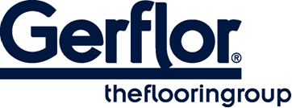 MURAL CLUB

MURAL CLUB is a homogeneous wall covering in 2m width roll and with a B-s2,d0 fire classification. It is designed to be a permanent wall covering.

It is hot welded with CR40 welding rods for better hygiene.

It is made of calendered layer with colour throughout the whole thickness for an nicer aspect of the welding. This layer comprises at least 10% of recycled products.
It does not contain any CMR 1 & 2 component and is 100% compliant with REACH.
It is 100% recyclable.

MURAL CLUB benefits from a PUR surface treatment which provided good resistance to chemical products and makes maintenance easier.

According to ISO 22196, MURAL ULTRA has anti-bacterial activity against E. coli, S. aureus and MRSA of 99% after 24h00.

Full resistant to impact, it acts as a buffer against damage from beds, trolleys and indoor motorized vehicles and other transportation systems.

MURAL CLUB is fully impact resistant and is therefore ideal for use as a cladding in large public buildings such as hospitals care institutions dental and veterinary surgeries, clean rooms, stores and supermarkets, warehouse and storage areas.

